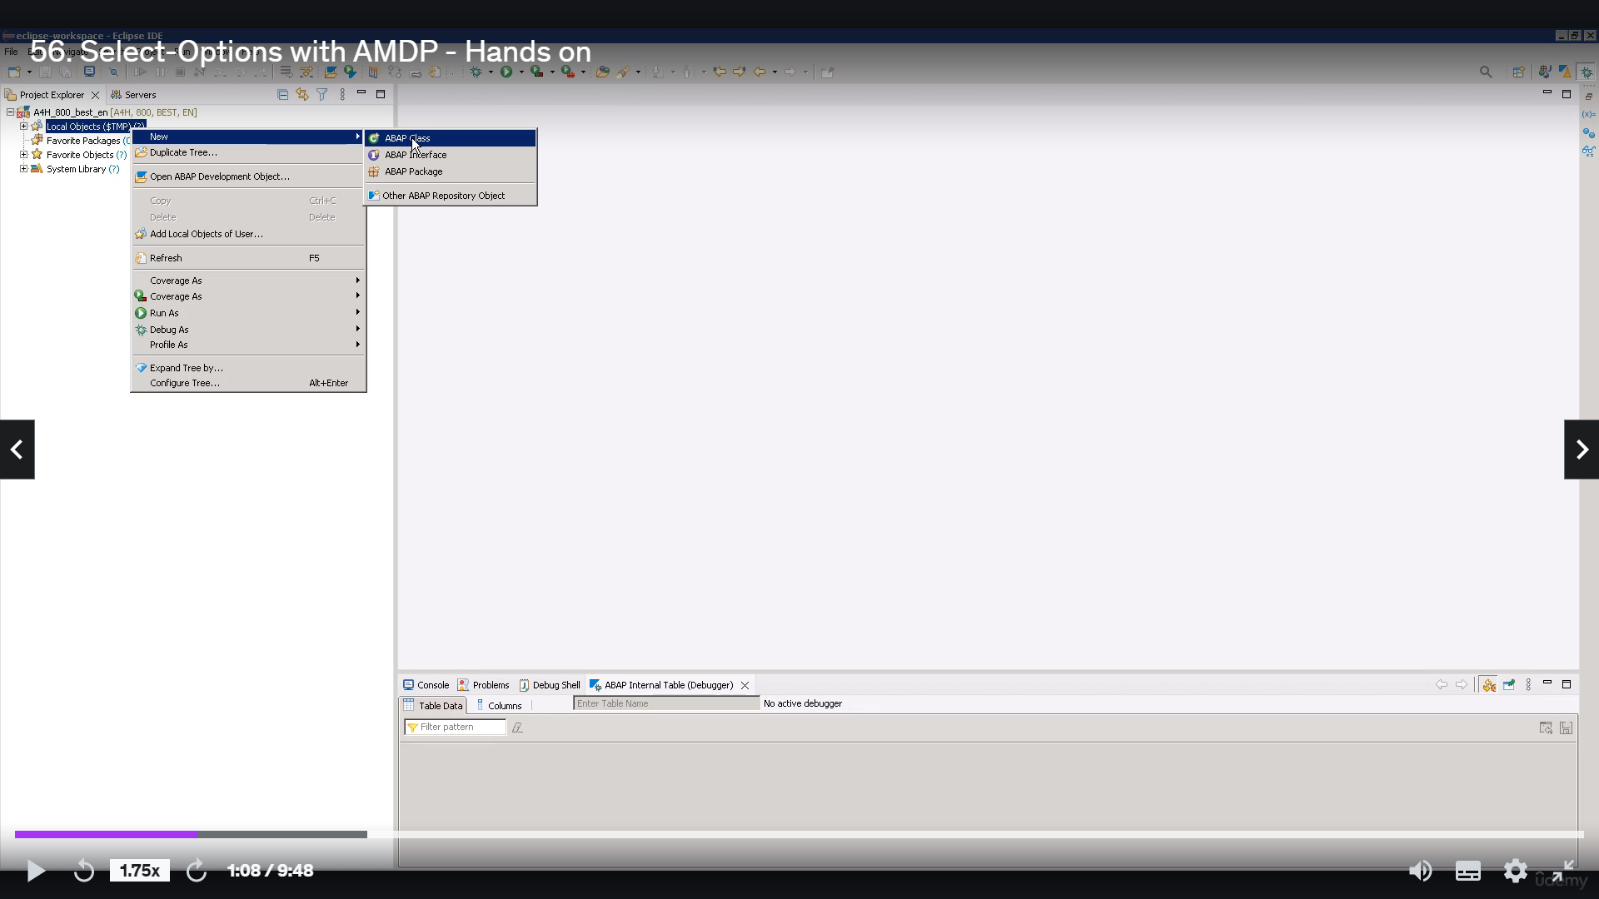

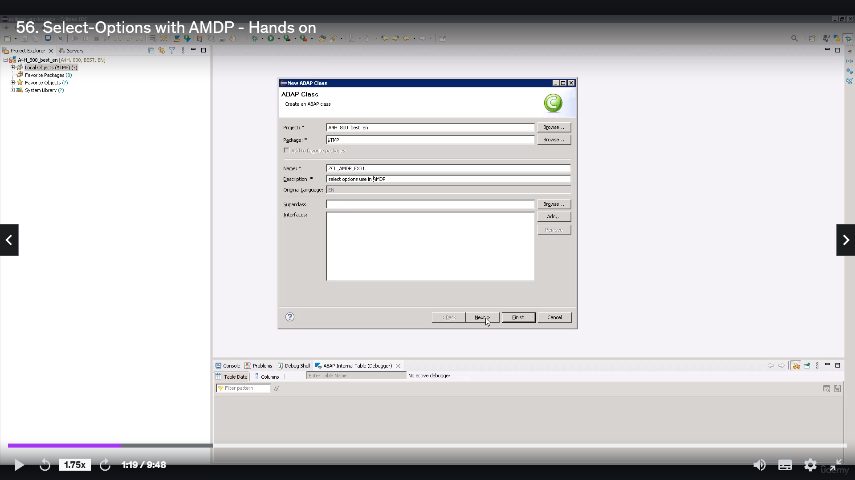

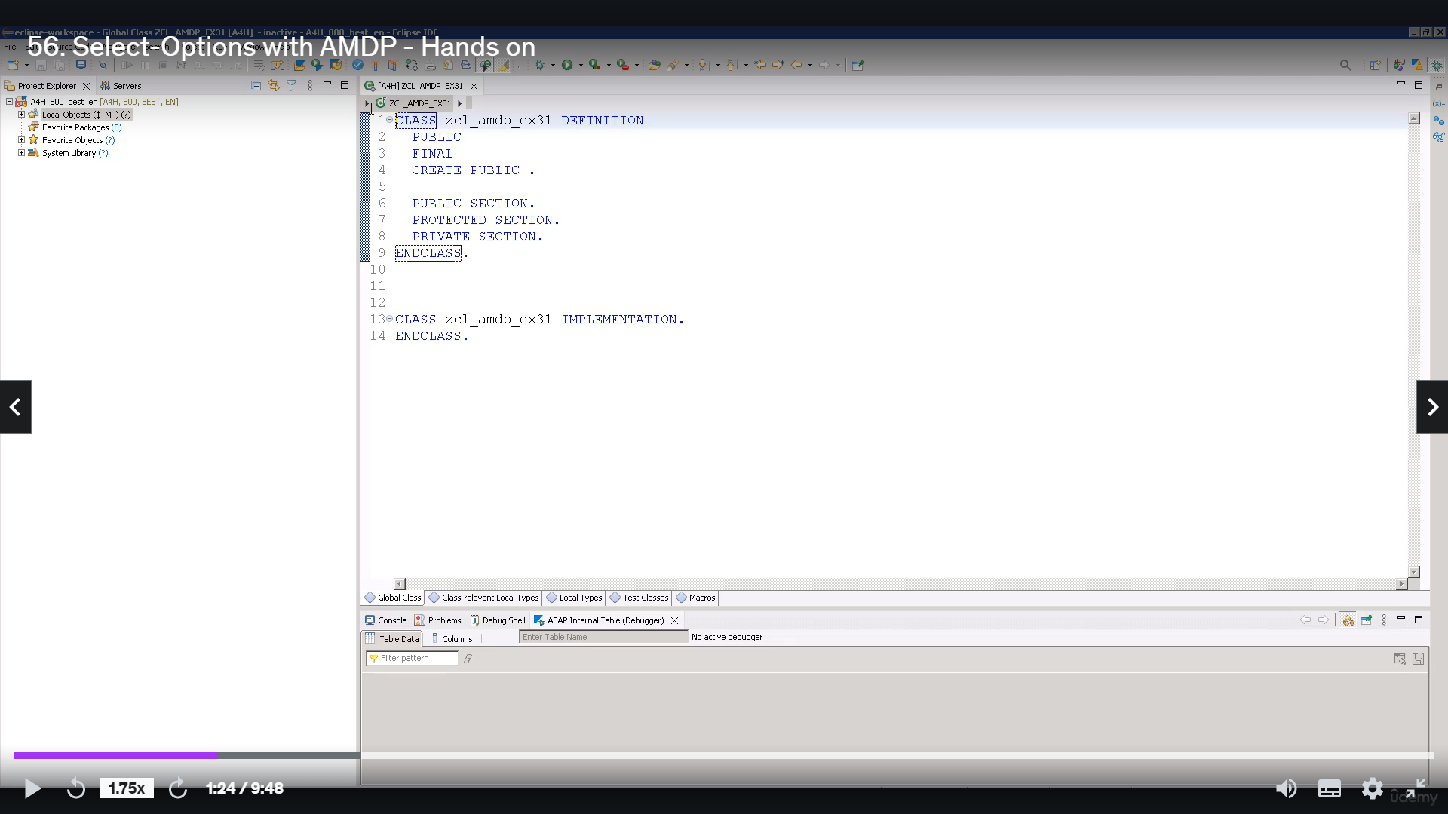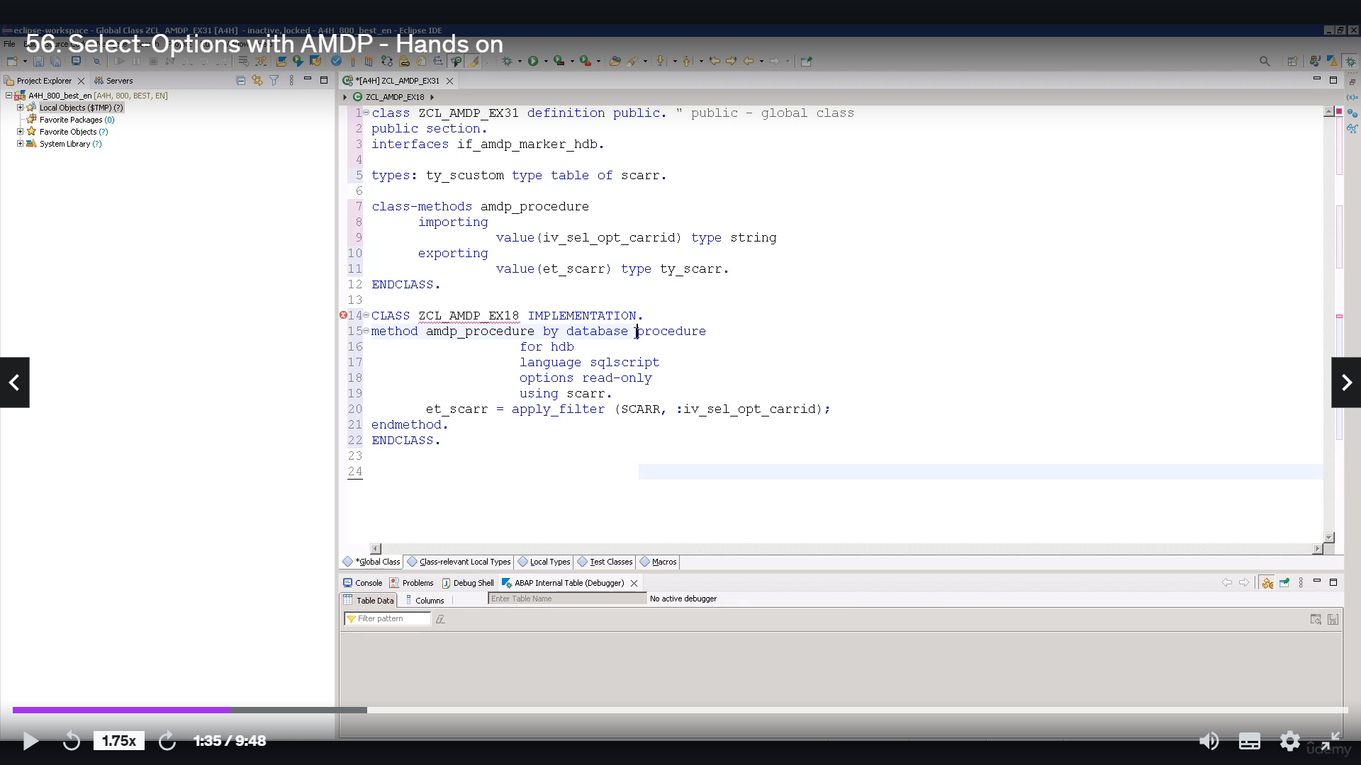

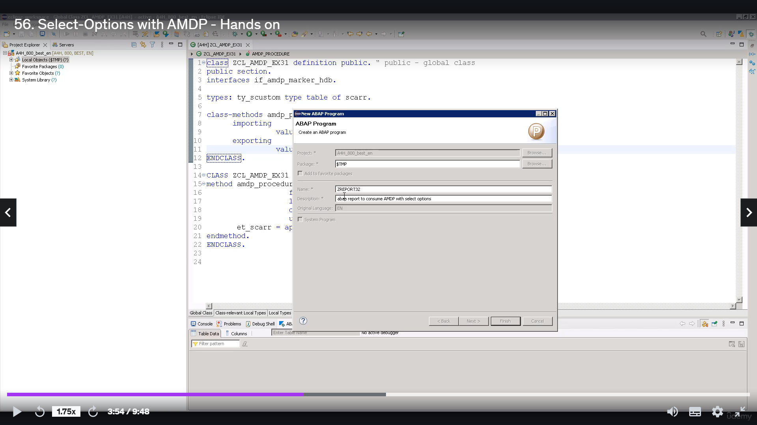

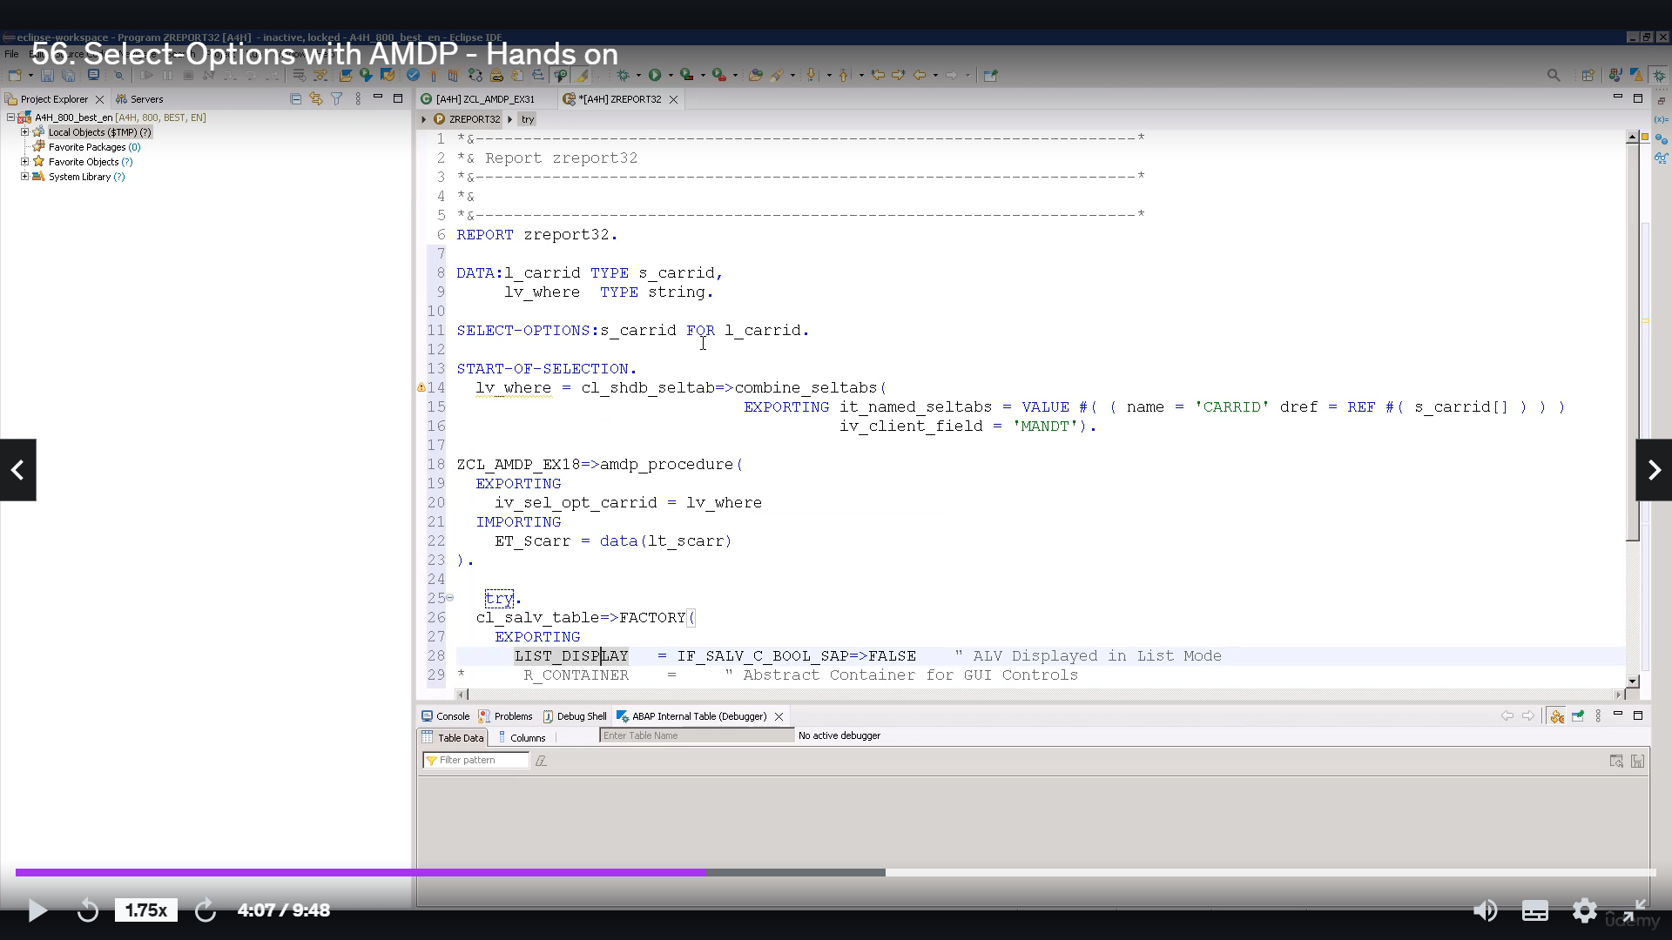

Hey, hey.

Welcome back in this video tutorial, I will discuss with you how to select option in MVP.

I'm assuming that when you are watching this video, you have already gone through terror related to

IMDb and hence the intrusion on this to reduce.

So you are well aware of the basic concept of MGP and how to consume MGP.

I bet Rupert.

So you attempt to attach two examples to resource files along with this video that you can use to create

MBP and ABP report to consume this MVP.

The main object of this video is not to explain the concept of IMDb and its condemn shooting people,

but how do you select option?

MTV?

Now, let's start.

So we will go to eclipse.

Will create one girl will have a plus.

There to seal IMDb example.

31.

I have given description at Select Option using IMDb.

Click Next and finish.

So this will create a basic template for our military class.

Since we already have the cold with this, we will simply copy pasted.

Let's quickly go to cold ones here.

We have a closet definition.

The class name is there, Trillium GP example thirty one.

He'll be have user interface.

I have IMDb maker HDB, and in definition we are defining when IMDb procedure with inputting parameter

IV.

Select Option Guarantee and with exporting parameter 80, the C.A.R..

So the input that we are passing to this MGP procedure is of type string and the output that we are

expecting out of this envelope procedure is of type B C error, which is nothing word of type table.

This zero, the table we have used here is a C++.

It's a flat water table in a.

This table contains airplane carrier related information.

We have to implement this M.V.P. procedure, mental retardation database procedure 408 abuse, the language

we are using here is this conscript option, really.

And here you have to positively see Arar.

We are exporting fake data through this tool, but.

Here you can see the whole use function apply filter.

The applied filter function expects to barometers.

The first one is a dataset to which you want to apply for.

And the second one is generated very close, which is buzz string argument.

OK, so it's pretty simple.

This quickly check and accurate.

No, we have to consume this MVP in other people, so for that purpose?

Let's create one out of every book.

It's good as 0.32, I'm giving description as a people to consume in the private select option.

OK, you can use the code provided to you.

Again, this report is very simple one.

Here we use select options.

Variable name is it.

And this could guarantee for.

El garrote, el guarantee is of type, it's.

OK, so it's it is basically the data element for clarity.

Then we have a one variable beware of type string.

So as we're already discussing today with you will be using combined select method of glass as a Double

Select tab to convert select option table into a string of very close.

Action, you have to buzz and intensity, but here we are creating the dinner table with new value operator.

In this internal debate, the name of relevant field name and dictator reference of corresponding select

option table B2 is required for each entry.

In case of relevance, it is recommended to specify the exporting parameter.

I recline through with client or amended to ensure the addition of Glenn Filter to the workload.

The matter returns do dynamic air condition as a stream, which can then be passed to IMDb meter.

Here we are getting the military procedure.

Of glass ceiling rip example to do one and real policy debate clustering.

And in return, we are expecting value in Table eight.

It's the order.

Then at last, this portion of code is included to display the content in the internal table, and it's

the.

OK, so it is very straightforward.

Now let's activate this one.

I hope you understand the logic is pretty simple, but simply, we are converting the select option

table into a very close string that we are clustering.

We are passing to implement procedure, namely the procedure method.

We are receiving that very close, and we are passing it to function a blow for the.

So basically, what it will does is it will simply out all the relevant information from table is correct

based on the workload that will help us through it.

OK, so now let's go to a report and let's execute this.

OK, let's pass some value to this select option.

And execute.

OK, so now you can see the output from table is to air with this to guarantee here AC.

OK.

So that means obviously the option is working perfectly fine.

Now what we can do is we will set a breakpoint.

To No.

14, Annie, namely P Tulane, No.

20.

OK, so exit from the screen and let's execute into one more time.

So as you can see here, the condolences to break point.

OK, let's double click on this variable.

We we're.

I'm doing this just to show you how the country didn't select option table will get converted into a

string of very close.

IPv6, OK.

Now you can see here the content in this variable.

These amended close to 800, which is our clanged and Kennedy, because school here are goes to the.

So basically this mater combined select AB is converting the select option values to one very close.

No, there's two effect.

It will take you to the next big point.

No, let's if six.

Now you can see the content in this video, but in this table, it is Ciara.

So basically, this a blow you to function.

This phasing out all the relevant information from Table Ishihara, based on the workload that we help

foster it and the result it's stored is zero.

Let's do affect.

And here is the output.

Now, I hope you understood how to use select options in IMDb.